NOTICE OF PUBLIC MEETING
MONTGOMERY COUNTY EMERGENCY SERVICES DISTRICT NO. 7

Notice is hereby given that MONTGOMERY COUNTY EMERGENCY SERVICES DISTRICT NO. 7 will hold a meeting on July 30, 2026 at 1:00 PM at the following location in the District: 13833 Highway 59 N. Splendora TX 77372

The District will consider and act upon the following matters:

- Call meeting to order, and establish a quorum.
- To receive public comment (3 minutes per person).
- To approve the minutes of prior meeting(s).
- To receive the District’s 2025 audit report and take any related action.
- To review and act on financial matters, including report from the District bookkeeper and Treasurer, to pay bills, determine investments, financial institutions/depositories, security agreements, and sales tax related items.
- To review, discuss and propose the District’s 2027 Budget.
This is an item to begin the Budget adoption process for the upcoming FY 2027. The District acknowledges the requirement of Government Code §551.043(c)(2) to prepare a taxpayer impact statement when reviewing and adopting budgets. However, certified values are not yet available and the required no new revenue tax rate calculations are not yet available. Therefore, no Taxpayer Impact Statement is included.
- To review, discuss and propose the District’s 2026 Tax Rate.
- To schedule a public hearing regarding the District’s 2026 tax rate and the date of the meeting to adopt.
- To authorize District Counsel to publish the necessary 2026 tax rate setting notices.
- To review and take action on matters relating to an election to be held on
November 3, 2026:
  - Approve an Order of Election under Texas Tax Code Section 26.07.
  - To review and take action to hold an election jointly with other jurisdictions.
  - To review and take action to contract with Montgomery County Elections Office for election services.
- To consider and take action on such other Orders, Resolutions and related matters as required or appropriate to call for the District election
- To review, discuss and act on communications regarding discontinuing service to areas outside of District.
- To review and act on items related to construction, improvements, repairs, and renovations of District facilities.
- To review and act on disposition of surplus and/or salvage property.
- To review and act to acquire supplies, technology, equipment and vehicles, including financing and approval of any necessary resolutions related to same.
- To review and act regarding real estate, including sale, purchase, financing, lease, platting, utilities, encumbrances and legal actions related to real estate.
- To receive a report on Fire Department operations and activities, including action to approve expenses related to equipment and training, and proposed personnel policies and benefits.
- To meet in Closed Session pursuant to Government Code §551.071 to consult with legal counsel regarding pending or contemplated litigation, settlement offers or on matters which require confidentiality under the Texas Disciplinary Rules of Professional Conduct of the State Bar of Texas and Tax Code §323.3022 to discuss sales tax matters.
- To meet in Closed Session pursuant to Government Code §551.072 to deliberate regarding real estate matters.
- To meet in Closed Session pursuant to Government Code §551.074 to discuss personnel matters.
- To review and act on items discussed in Closed Session.
- To review, discuss and act on personnel matters.
- Review, discuss and take action to confirm the date for any future meetings.
- Adjournment.

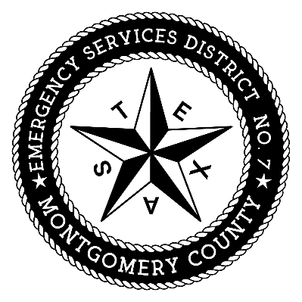
Montgomery County
Emergency Services District No. 7

By: _______________________________

David Manley, District Counsel
Coveler & Peeler, p.c.
Two memorial city plaza
820 Gessner, Suite 1710
Houston, Texas 77024
Telephone: (713) 984-8222
Email: manley@coveler.com

